A Project Report

On

**Car Rental**

Submitted in partial fulfillment of the requirement of

Project-IV (BIT279CO)

Of

Bachelor of Information Technology

**Submitted to**



Purbanchal University

Biratnagar, Nepal

**Submitted By**

RAJU BHATTARAI(343595)

KAMAL BARAILI(343591)

BHANUBHAKTA BELBASE(343587)

**KANTIPUR CITY COLLEGE**

Putalisadak, Kathmandu

August 26, 2022

A Project Report

on

**Car Rental**

Submitted in partial fulfillment of the requirement of

Project-IV (BIT279CO)

Of

Bachelor of Information Technology

**Submitted to**



Purbanchal University

Biratnagar, Nepal

**Submitted By**

RAJU BHATTARAI (343595)

KAMAL BARAILI (343591)

BHANUBHAKTA BELBASE (343587)

**Project Supervisor**

**Mr Ashim KC**

Lecturer

**KANTIPUR CITY COLLEGE**

Putalisadak, Kathmandu

August 26, 2022

# TOPIC APPROVAL SHEET

The undersigned certify that they have been read and recommended to the Department of Information Technology for acceptance, a report entitled “Car Rental” submitted by:

1. Kamal Baraili
2. Raju Bhattarai
3. Bhanubhakta Belbase

In partial fulfillment for the degree of Bachelor in Information Technology

………………….....

Mr Ashim KC Project Coordinator Kantipur City College

………………….....

Mr Saroj Pandey

HOD, IT Department

Kantipur City College

# CERTIFICATE FROM SUPERVISOR

This is to certify that the project entitled “Car Rental” submitted by Raju Bhattarai, Kamal Baraili and Bhanubhakta Belbase to the department of Science and Technology at Kantipur City College, Kathmandu, Nepal towards the requirement for BIT of is an original work carried out by them under my supervision and guidance.

Signature:

-------------------------------------

Mr Ashim KC

Project Supervisor

Kantipur City College

Putalisadak, Kathmandu

# ACKNOWLEDGEMENT

We would like to express the deepest appreciation to our supervisor Mr. Ashim KC who has an attitude and the substance of genius: he continually and convincingly conveyed a spirit of adventure in regard to research and an excitement in regard to guiding to study and preparing this report. Without his guidance and persistent help, this report would not have been possible.

We would like to thank our college principal Mr.Raju Kattel for providing us this golden opportunity to express and innovate our ideas in the form of this project.

We would like to thank all our classmates for their continuous help and co operation to finish this report smoothly in time

# ABSTRACT

Our Aim is to design and create a system for car renting by paying the system for a specified period of time, so customers can rent a car. This system increases customer retention and simplifies the vehicle renting process.

Our system has a very user-friendly interface. Thus the users will feel very easy to work on it. By using this system, customers can add their personal information and rent cars easily. The customer should create a new account before logging in or he/she can log into the system with his/her created account. There is no delay in the availability of any car information, whenever needed the car information can be accessed very quickly and easily.

**Table of Contents**

TOPIC APPROVAL SHEET

CERTIFICATE FROM SUPERVISOR

ACKNOWLEDGEMENT i

ABSTRACT ii

List of Figures v

List of Tables vi

Chapter 1: Introduction 1

1.1 Project Introduction 1

1.2 Problem Statement 1

1.3 Objective Of The Project 1

1.4 Significance Of The Project 2

1.5 Project Features 2

1.6 Assignment Of Roles and Responsibilities 3

1.7 Documentation Organization 4

Chapter 2: Existing System Overview 5

Chapter 3: System Analysis 6

3.1 Software Development Model 6

3.2 Requirement Specification 7

3.2.1 Functional Requirement 7

3.2.2 Non-Functional Requirement 7

3.3 Feasibility study 8

3.3.1 Technical Feasibility 8

3.3.2 Economical Feasibility 8

3.3.3 Schedule Feasibility 8

Chapter 4: System Design 10

4.1 Context Diagram 10

4.1.1 Dfd Level 1 Diagram 11

4.2 Use Case Diagram 12

4.3 Er Diagram 13

Chapter 5: System Development and Implementation 14

5.1 Programming Platform 14

5.1.1 Front-end Web Development 14

5.2 Operating environment 14

5.2.1 Software Requirement (Tested on) 14

5.2.2 Hardware Requirement 14

5.3 Testing and Debugging 15

Chapter 6: Conclusion 16

6.1 Conclusion 16

6.2 Limitation 16

6.3 Future enhancement 16

# List of Figures

**Figure 1: Prototype Model 6**

**Figure 2: Gantt Chart 9**

**Figure 3: Context Diagram 10**

**Figure 4: Dfd level 1 11**

**Figure 5:Use case Diagram 12**

**Figure 6: Er diagram 13**

# List of Tables

**Table 1. Assignment of roles and responsibilities Error! Bookmark not defined.Table 2. Documentation Organization Error! Bookmark not defined.Table 3: Testing and debugging.** 16

# Chapter 1: Introduction

## 1.1 Project Introduction

Car rental system is a web based system for a company that rents out cars. This system enables a company to make their services available to the public through the internet. This system rents cars for a short period of time, for a few days or weeks. Car rental system operates by charging certain rental charges. It also helps the users to search for available cars easily with the use of an interface which helps the users to check for cars and rent them for the period specified based on the customer ,the user shall be able to make bookings. This car rental system makes the booking easy. It saves time by providing information like car type etc. easily when needed. Our system shall help the customer to book a car for a journey.

## 1.2 Problem Statement

A manual car rental system provides services only during office hours. So customers have limited time for bookings of the cars. The existence of a car rental system which is online based can overcome the limitation of the business operation hour. Manual car rental systems need customers to go to the nearest office to register as a client and have low reach to the customer as it involves a lot of paperwork and consumes time. Our system provides a way to overcome all this problem by performing the tasks digitally & easily and in a more understandable way.

## 1.3 Objective Of The Project

* To reach customers and provide car renting services.

## 1.4 Significance Of The Project

* + Reach many customers

As our system is based online it can reach customers easily through the internet which will increase the tendency of a customer making a booking on the spot very high.

* + Automated booking management

Car rental can make employees productive in other aspects as they won't be tired of the phone for booking calls.

* + 24/7 operation

Our car rental system works all the time. Potential guests will book vehicles anytime they need. This technique additionally maximizes the revenue since operating hours aren't restricted.

## 1.5 Project Features

* login and Registration.
* Browse car information.
* Car details.
* Car booking.

## 1.6 Assignment Of Roles and Responsibilities

|  |  |  |
| --- | --- | --- |
| **Members Name** | **Symbol Number** | **Task performed** |
| Kamal Baraili | 343591 | coding and Documentation. |
| Raju Bhattarai | 343595 | Designing, coding and Documentation. |
| Bhanubhakta Belbase | 343587 | Designing and coding. |

**Table 1.1: Assignment of roles and responsibilities**

## 1.7 Documentation Organization

|  |  |
| --- | --- |
| **Chapters** | **Heading** |
| Chapter 1 | Project Introduction |
| Chapter 2 | Existing System Overview |
| Chapter 3 | System analysis |
| Chapter 4 | System Design |
| Chapter 5 | System development and implementation |
| Chapter 6 | Conclusion |

**Table 1.2:Documentation Organization**

# Chapter 2: Existing System Overview

**System 1: Kathmandu Car Services**

Kathmandu car services provides a car rental service which is easy to book , whatever your budget, with multiple car choices.

**Pros**

* Flexibility in travelling.
* Varieties of vehicles.

**Cons**

* Driver needs to be hired along with the car.
* Confusing interface.

**System 2: Self Drive Nepal**

Self Drive Nepal is Nepal's largest self drive vehicle rental company. With just a touch, book your next drive for all over Nepal.

**Pros**

* Easy to use and book cars.
* Affordable price.

**Cons**

* Complex interface.

# Chapter 3: System Analysis

## 3.1 Software Development Model

The basic idea here is that instead of freezing the requirements before a design or coding can proceed , a throwaway prototype is built to understand the requirements. This prototype is developed based on the currently known requirements. By using this prototype, the client can get an “actual feel” of the system, since the interactions with the prototype can enable the clients to better understand the requirements of the desired system. Prototyping is an attractive idea for complicated and large systems for which there is no manual process or existing system to help determine the requirements. The prototypes are usually not complete systems and many of the details are not built in the prototype. The goal is to provide a system with overall functionality.

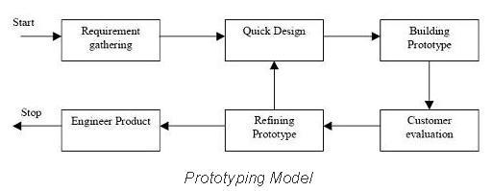

**Figure 3.1: Prototype Model**

## 3.2 Requirement Specification

### 3.2.1 Functional Requirement

This section provides a requirements overview of the system. Various functional models that can be implemented by the system will be:

* **Registration**

If a customer wants to rent a car then he/she must be registered.

* **Login**

Customers login to the system by entering valid username and password for the booking.

* **Booking**

The system allows the customer to register for booking . The system allows the customer to view detailed descriptions of particular cars . The system allows customers to view a list of available cars during booking.

### 3.2.2 Non-Functional Requirement

* **Security**

The system provides a high level of security and integrity of data held by the system, only authorized customers can gain access to the users information using valid username & password.

* **Usability**

The system provides a menu in all interfaces for the user to interact with the system.

* **Availability**

The system is always available for access at 24 hours ,7 days a week.

## 3.3 Feasibility study

### 3.3.1 Technical Feasibility

The system is created to match the technology , which is found in almost all recent computers. There is no special hardware requirement that has to be attached separately. Hence, we believe that the designed system is technically feasible.

### 3.3.2 Economical Feasibility

The proposed system only requires devices that can access web applications. It doesn’t require any special hardware/software purchases on the side of users. The system is beneficial with regards to time and other resource required

### 3.3.3 Schedule Feasibility

During this study we studied whether the system is either socially accepted or not, and the system follows the policy of the organization. In addition, the labor required after the completion of the study.

### 

### 

|  |  |  |  |  |  |  |
| --- | --- | --- | --- | --- | --- | --- |
| **S.N.** | **Tasks** | **April** | **May** | **June** | **July** | **August** |
| **1.** | **Concept Submission** |  |  |  |  |  |
| **2.** | **Requirement Gathering** |  |  |  |  |  |
| **3.** | **System Analysis & Designing** |  |  |  |  |  |
| **4.** | **Coding** |  |  |  |  |  |
| **5.** | **Testing and debugging** |  |  |  |  |  |
| **6.** | **Documentation** |  |  |  |  |  |

**Index:**

|  |  |
| --- | --- |
| **Task completed** |  |

**Figure 3.2: Gantt Chart**

# Chapter 4: System Design

## 4.1 Context Diagram

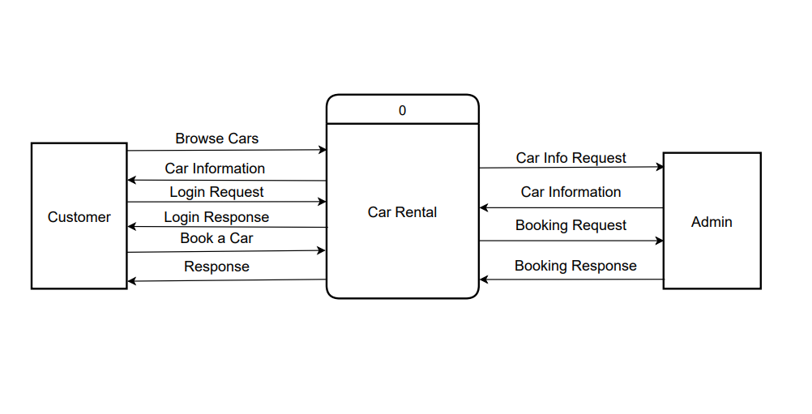

**Figure 4.1: Context Diagram**

### 4.1.1 DFD Level 1 Diagram

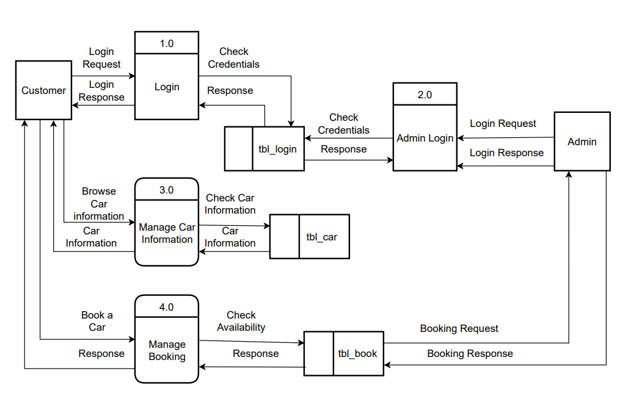

**Figure 4.2: Dfd level 1**

## 4.2 Use Case Diagram

# car use case.png

**Figure 4.3:Use case Diagram**

## 

## 4.3 ER Diagram

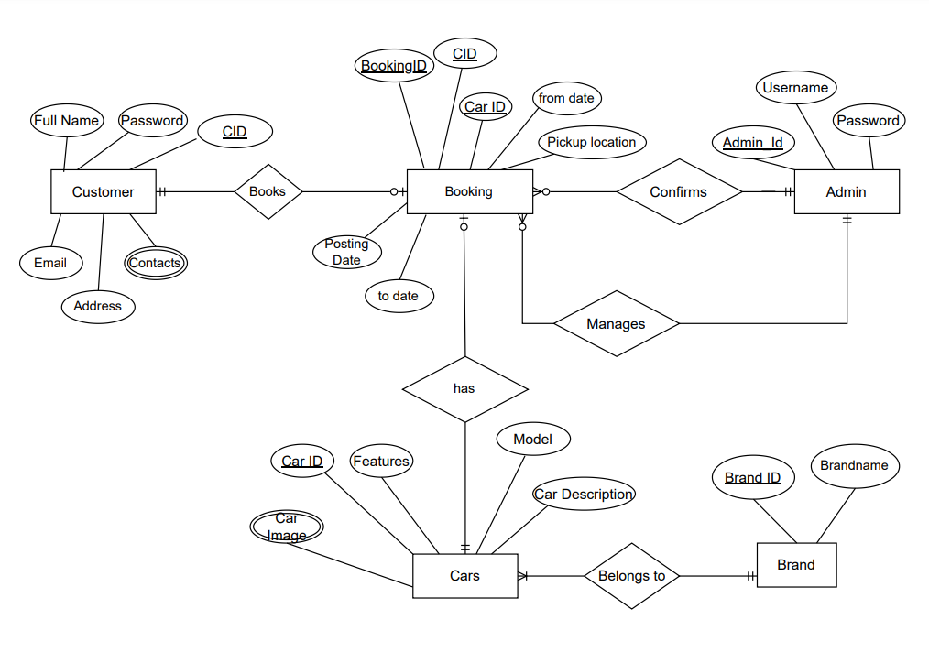

**Figure 4.4: ER diagram**

# Chapter 5: System Development and Implementation

## 5.1 Programming Platform

* Visual studio code is used as an IDE.

### 5.1.1 Front-end Web Development

* HTML 5
* JavaScript ES6
* CSS

## 5.2 Operating environment

### 5.2.1 Software Requirement (Tested on)

Operating System: Windows 10

Browser: Mozilla Firefox 103.0.2(64-bit)

### 5.2.2 Hardware Requirement

Processor: i3

System Bus: 64 bit

RAM: 4GB

HDD: 1 TB

## 5.3 Testing and Debugging

Testing in a project development is a very important task to find out the possible mistakes made by the developers. The system cannot give the correct output until the project contains no errors at all. This project has checked the possible errors by using the following approaches.

|  |  |  |  |  |
| --- | --- | --- | --- | --- |
| **S.N.** | **Input** | **Expected Output** | **Actual Output** | **Status** |
| 1. | To check whether forms fields are valid or not | All form fields should take valid inputs only. | Email field was not validated. | fail |
| 2. | To check whether forms fields are valid or not | All form fields should take valid inputs only. | All fields were successfully validated. | Pass |
| 3. | To check the flow of the project. | The pages should be loaded in the proper order they are clicked. | The pages loaded in the proper order. | Pass |
| 4. | To check whether the project content is hidden due to overflow. | No content should be hidden. | No content was found hidden. | Pass |
| 5. | Used Custom library for fonts | All fonts should be the same. | All fonts were found the same. | Pass |
| 6. | Use js to slide images | All images should slide. | All images were not slided | Fail |
| 7. | Use js to slide images | All images should slide. | All images were slided. | Pass |

**Table 5.1: Testing and debugging.**

# Chapter 6: Conclusion

## 6.1 Conclusion

Car rental system was successfully created and the web application was tested very well and the errors were properly debugged. Testing also concluded that the performance of the system is satisfactory. All the necessary output is generated.

## 6.2 Limitation

* No database and site is still static.

## 6.3 Future enhancement

* It can be made user customizable.